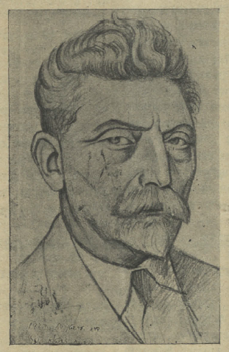
Dr. Chaim Zhitlowsky. Image Source: Literarishe bleter 12, no. 21 (24 May 1935), 324.

